PROJECT REPORT
INCIDENT LIFECYCLE AUTOMATION IN SERVICENOW
A ServiceNow-based solution for managing IT incidents from recording to closure
Project Details Information
Item | Details
Student Name | Varanasi Keerthana
Department | Computer Science and Engineering (CSE)
Institution | Lendi Institute of Engineering and Technology
Project Platform | ServiceNow Service Portal
Academic Year | 2026–2027

1. INTRODUCTION

1.1 Project Overview
Incident Lifecycle Automation in ServiceNow is an IT service-management project designed to organize how incidents are handled from the moment they are reported until they are closed. The system supports incident recording, classification, assignment to support groups, investigation using knowledge articles and work notes, linking of related incidents and change requests, SLA tracking, and resolution and closure. It uses the ServiceNow platform to maintain related records and support role-based work for employees (callers), service desk agents, support group members, service desk managers, and administrators.
The project aims to make incident handling more consistent for service desk staff and more transparent for the employees who report issues, by bringing incident details, ownership, knowledge, related records, and SLA information into one connected workflow.

1.2 Purpose
The purpose of this study is to develop an incident lifecycle solution using the ServiceNow platform to simplify and improve the daily work of an IT service desk. The solution is designed to manage incident recording, classification, assignment, investigation, related records, SLA tracking, and resolution within a single platform.
The study aims to reduce incomplete incident records, unclear ownership, and repeated troubleshooting, and to make it easier for employees to report issues and for support staff to track progress. It also helps the service desk record resolution details in an organized manner so that they can be reused for future incidents. By using ServiceNow features, the solution provides a centralized platform with role-based access for employees, service desk agents, support group members, managers, and administrators.
Overall, the study focuses on making incident handling more consistent, improving record quality, reducing manual coordination, and providing a simple and organized way to manage the incident lifecycle.

1.3 Objectives
- To record incidents with complete and consistent details.
- To classify incidents by category, subcategory, impact, urgency, service, and configuration item.
- To assign incidents to the correct support group with clear ownership.
- To support investigation with knowledge articles, work notes, related incidents, and change requests.
- To make SLA status visible and record resolution details for future reference.

1.4 Scope of the Project
The scope covers the incident lifecycle in ServiceNow: recording, classification, assignment, investigation, related records, SLA tracking, resolution, closure, and notifications, for five roles: employee (caller), service desk agent, support group member, service desk manager, and administrator. Automatic incident creation from monitoring tools, machine learning-based classification, and a dedicated mobile application are not part of the current version and are listed under Future Scope.

2. IDEATION PHASE

2.1 Problem Statement
IT service desks often face difficulties in handling incidents consistently. Incidents may be recorded with missing or inconsistent details, classified differently by different agents, routed to the wrong support group, or investigated without using knowledge that already exists. These problems can lead to delays, repeated work, unclear ownership, and difficulty in tracking progress against service level agreements (SLAs).
Employees who report incidents may be unsure whether their problem has been understood and who is working on it, while support staff may need to contact the caller repeatedly, reassign incidents, or search several places for related records and knowledge. When resolution details such as the cause, workaround, and work notes are not recorded completely, the same issue may be investigated again from the beginning the next time it occurs.
To address these challenges, the proposed project, “Incident Lifecycle Automation in ServiceNow,” aims to build a structured incident workflow on the ServiceNow platform. The solution is designed to capture complete incident details, classify incidents consistently, assign them to the correct support group, support investigation with knowledge and related records, make SLA information visible, and require resolution details before an incident is closed.
The customer problem statements for the main user groups are summarized below.
Item | PS-1: Reporting and classifying incidents | PS-2: Assignment and ownership | PS-3: Investigation and knowledge reuse
Problem  Statement | A user needs to report an IT issue with enough detail for support staff to understand and classify it correctly. | A service desk agent needs incidents to reach the support group that can investigate them. | A support group member needs to investigate and resolve an incident without repeating work already done.
I am  (Customer) | An employee experiencing an IT service problem. | A service desk agent managing incoming incidents. | A support group member working on assigned incidents.
I’m trying to | Report the issue clearly and provide the information needed to begin troubleshooting. | Classify the incident, assign it to the correct group, and make the next action clear. | Find known fixes, review related records, and record what was done.
But | I may not know which details  are important, and the incident may be recorded with incomplete or inconsistent information. | An incident may need reassignment or clarification before the right technician can start work. | Knowledge, related incidents, and change requests are hard to find, and notes are written in different styles.
Because | Different incidents require different classification details  such as category,  subcategory, urgency, service, and configuration item. | The issue may require specific technical expertise, and assignment details must be accurate and up to date. | Information is spread across records and is not always linked to the incident.
Which makes me feel | Unsure whether my problem has been understood and concerned that support may be delayed. | Concerned about delays, unclear ownership, and extra coordination. | Frustrated by repeated troubleshooting and uncertain about SLA deadlines.

2.2 Empathy Map Canvas
The empathy map below is prepared from the perspective of the service desk agent, who records, classifies, assigns, and follows incidents through the lifecycle.
Empathy Area | Service Desk Agent Perspective
Says | “I need complete details so I can classify and assign this incident correctly.”
Thinks | “Will this incident be fixed correctly and before the SLA is breached? Who owns it?”
Does | Asks callers for category and urgency, assigns support groups, searches knowledge articles, updates work notes, and records resolution details.
Hears | Callers asking for updates, managers reminding the team about SLA targets, and resolver groups saying an incident belongs to another team.
Sees | Incidents with missing details, queues waiting for assignment, SLA timers counting down, and related records spread across places.
Feels | Worried about missing details, unclear ownership, and SLA deadlines, and frustrated by repeated work.
Pain Points | Incomplete records, wrong category or urgency, reassignment delays, repeated troubleshooting, and hard-to-track SLAs.
Needs / Gains | Consistent records, fast and correct assignment, reuse of knowledge, a clear view of status and SLAs, and complete resolution notes.

User Persona:
Persona Detail | Description
User | Service Desk Agent (primary user)
Role | First point of contact who records, classifies, assigns, and follows incidents through the lifecycle.
Goals | Record complete details, classify consistently, route incidents to the right group, and close them with clear resolution notes.
Frustrations | Missing details, wrong routing, repeated troubleshooting, and unclear SLA status.
Tools Used | ServiceNow incident form and lists, knowledge articles, work notes, and email notifications.
Motivation | Resolve incidents quickly and correctly while keeping callers informed.

Key Observations from the Empathy Map:
- Most pain points begin at the first step, when incident details are missing or inconsistent.
- Uncertainty about ownership and reassignment causes delays and extra coordination.
- Knowledge and related records are not always easy to find, which leads to repeated work.
- SLA deadlines create pressure, so status must be visible without searching.
- A complete resolution record gives lasting value for future incidents.

The empathy map canvas for this user is shown in Figure 1.
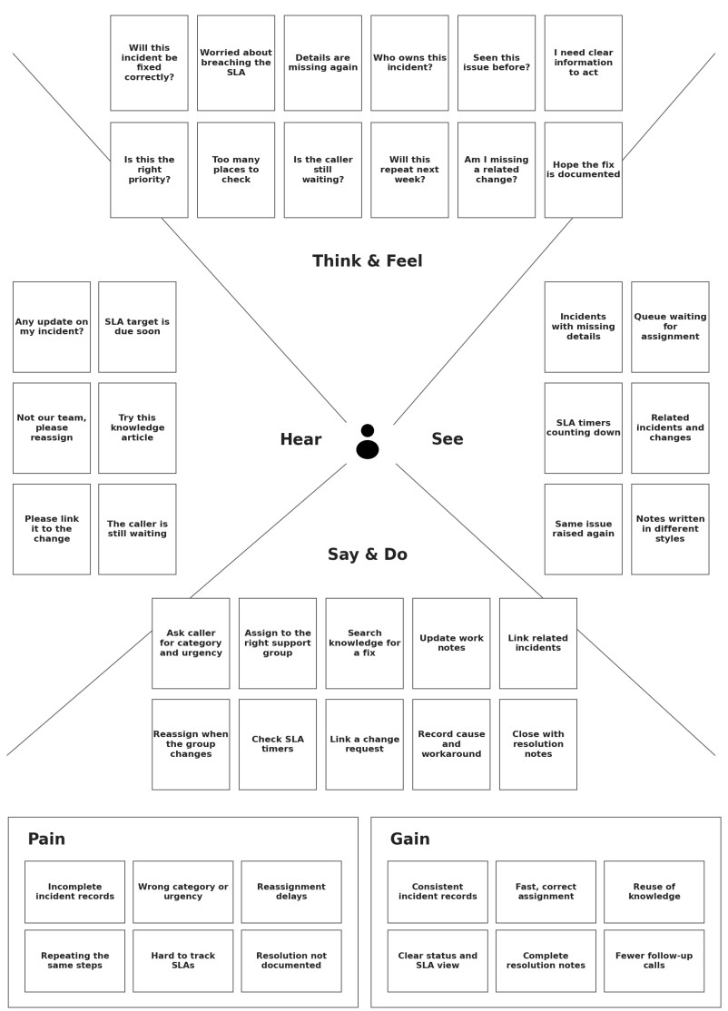
Figure 1: Empathy Map Canvas – Service Desk Agent

2.3 Brainstorming
- Provide a single place to report, classify, and follow IT incidents.
- Capture complete incident details, including caller, short description, and detailed description.
- Classify incidents consistently using category, subcategory, impact, urgency, service, and configuration item.
- Assign incidents to the correct support group and record reassignment with a note.
- Allow agents and support groups to search and attach knowledge articles and add work notes.
- Link related incidents and change requests to the incident record.
- Show SLA status and warn users before an SLA is breached.
- Require cause, workaround, and resolution notes before an incident is resolved, and notify the caller.
- Provide managers with incident reports by category, priority, and state.

3. REQUIREMENT ANALYSIS

3.1 Customer Journey Map
Stage | User Action | System / Staff Support | Expected Outcome
Report | Employee reports an IT issue through the Service Portal or by contacting the service desk. | Creates an incident record with caller and description details. | Incident is recorded and an incident number is issued.
Classify | Agent selects category, subcategory, urgency, service, and configuration item. | Calculates priority from impact and urgency. | Incident is classified consistently.
Assign | Agent assigns the incident to a support group. | Places the incident in the group’s queue. | The correct group can see and own the incident.
Investigate | Support group searches knowledge, adds work notes, and links related incidents and change requests. | Shows articles and related records on the incident. | Investigation is documented and repeated work is reduced.
Track SLA | Agent or manager checks SLA status. | Displays SLA timers and warns before a breach. | Deadlines are visible and can be acted on.
Resolve and  Close | Support group records cause, workaround, and resolution notes and closes the incident. | Notifies the caller of the resolution. | Incident is closed with a complete record.

3.2 Solution Requirement
Category | Requirements
Functional | Incident recording; incident classification; assignment and ownership; investigation and knowledge reuse; related records (related incidents and change requests); SLA tracking; resolution and closure; notifications and reporting; access and configuration.
Non-functional | Usability, security, reliability, performance, availability, scalability, maintainability, and auditability.
User Roles | Employee (caller), service desk agent, support group member, service desk manager, and administrator. Access should be restricted according to assigned roles.
Data | Caller and incident details, classification fields, assignment group and owner, work notes, knowledge articles, related incidents and change requests, SLA records, and resolution details.
Platform | ServiceNow platform with Incident Management, Service Portal, Knowledge Management, Service Level Management, and workflow or business-rule capabilities as configured.

Category | Requirements
Security | Use authenticated access with role-based and record-level access controls. Incident records should be available only to authorized users, and changes should be recorded in the activity history.

3.3 Data Flow Diagram
Level 0 – Context description: The employee reports incidents and receives status updates and a resolution notification. The service desk agent classifies incidents, assigns them to support groups, and adds work notes. Support group members investigate incidents, update work notes and status, and record resolution details. The service desk manager receives SLA alerts and reports. The administrator configures categories, assignment groups, SLA definitions, and roles; these configuration activities are outside the incident data flow and are therefore not drawn in the diagram.
External Entity | Data Sent to System | Data Received from System
Employee (Caller) | Incident details | Incident number, status updates, resolution notification
Service Desk Agent | Classification details, assignment decision, work notes and updates | Incident records and SLA alerts
Support Group  Member | Work notes, status, resolution details, change request link | Assigned incidents
Service Desk Manager | Reporting and monitoring requests | SLA alerts and reports

Level 1 – Main processes: (1) Record and Classify Incident, (2) Assign Incident, (3) Investigate
Incident, (4) Resolve and Close Incident, and (5) Track SLA. The processes read and update
four data stores: D1 Incident Records, D2 Knowledge Base, D3 Change Requests, and D4 SLA Records.
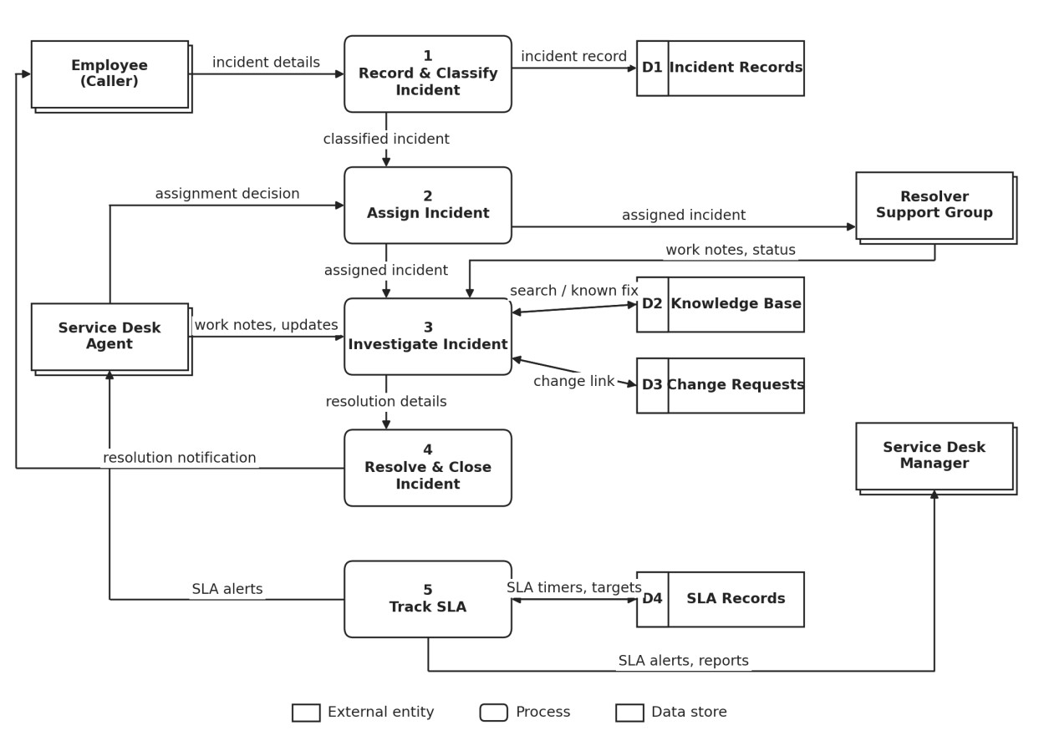
Figure 2: Data Flow Diagram (Level 1)

3.4 Technology Stack
The solution is built on the ServiceNow platform and uses its built-in applications and configuration tools rather than a separate custom application. The table below lists the technologies and areas used in the project and the purpose of each.
Technology / Area | Project Use
ServiceNow Platform | Core platform for records, forms, access control, and workflow configuration.
Incident Management | Recording, classification, assignment, and resolution of incidents.
Service Portal | Employee-facing interface for reporting and viewing incidents.
HTML, CSS, JavaScript | Portal interface components, styling, and client-side interactions where configured.
AngularJS and Bootstrap | Front-end frameworks used by Service Portal widgets.
ServiceNow Tables | Storage of incident, task, knowledge, change request, and SLA records.
Knowledge Management | Knowledge articles searched and attached to incidents.
Service Level Management | SLA definitions, timers, and status on incidents and tasks.
Business Rules / Flow Designer | Automation and record updates where implemented.
Email Notifications | Messages to callers and support groups on assignment and resolution.
Roles and ACLs | Role-based and record-level access control.
Attachments | Files such as screenshots or logs added to an incident.

Technology Mapped to the Incident Lifecycle:
Lifecycle Stage | ServiceNow Capability Used
Record | Incident form and Service Portal for entering caller and description details.
Classify | Category and subcategory fields, impact and urgency, priority calculation, and service and configuration item fields.
Assign | Assignment groups and assignment rules to route the incident and record the owner.
Investigate | Knowledge Management, work notes, related incidents, and linked change requests.
Track SLA | Service Level Management timers and status on the incident.
Resolve and Close | Resolution fields for cause, workaround, and notes, state change, and email notification to the caller.

Together, these technologies allow the incident lifecycle to be configured on a ServiceNow cloud instance and used through a web browser, so no separate server or database needs to be set up. Security is handled through ServiceNow authentication, roles, and access control rules, and changes to an incident are recorded in its activity history.

4. PROJECT DESIGN

4.1 Problem Solution Fit
Problem Identified | Proposed Fit
Incomplete or inconsistent incident details | Structured incident form with required fields and consistent classification.
Unclear ownership and reassignment delays | Assignment to support groups with a clear owner and a note recorded on reassignment.
Repeated troubleshooting for similar issues | Knowledge articles and related incidents linked to the incident record.
Related changes hard to connect to incidents | Change requests created or linked from the incident.
SLA deadlines hard to track | SLA timers and status shown on the incident and its tasks.
Resolution details skipped at closure | Cause, workaround, and resolution notes required before the incident is resolved.

4.2 Proposed Solution
The proposed solution is a ServiceNow-based incident lifecycle workflow that connects employee-facing activities with service desk and support group work. Employees can report issues, and service desk agents can record and classify incidents using consistent fields and assign them to the correct support group. Support group members can investigate using knowledge articles, related incidents, change requests, and work notes, and record the cause, workaround, and resolution before closing the incident.
Managers can view SLA status and receive alerts when an SLA is close to breaching, and administrators can maintain categories, assignment groups, SLA definitions, and user roles. The solution is intended to improve consistency, reduce avoidable manual coordination, and make the progress of every incident easier to follow.
Key Features of the Solution:
- Structured incident form with required fields for complete recording.
- Consistent classification and automatic priority calculation from impact and urgency.
- Group-based assignment with a recorded note when an incident is reassigned.
- Knowledge articles, related incidents, and change requests available from the incident.
- SLA timers and alerts that make deadlines visible.

4.3 Solution Architecture
Layer | Components / Responsibility
Presentation Layer | Service Portal pages and the ServiceNow Incident form and lists for reporting, classification, assignment, and tracking.
Layer | Components / Responsibility
Application / Logic  Layer | ServiceNow business rules, assignment rules, flows, and form logic that process incidents, calculate priority, and run SLA and notification logic.
Data Layer | ServiceNow tables for incident, task, knowledge, change request, and SLA records, along with attachments.
User / Access Layer | Employee, service desk agent, support group member, manager, and administrator roles with appropriate access controls.
Integration Layer | Email notifications to callers and support groups, and an optional REST API for integration with other systems.

Workflow: Employee or agent action → Service Portal / Incident form → validation and configured logic → ServiceNow record update → notification and status made available to authorized users.
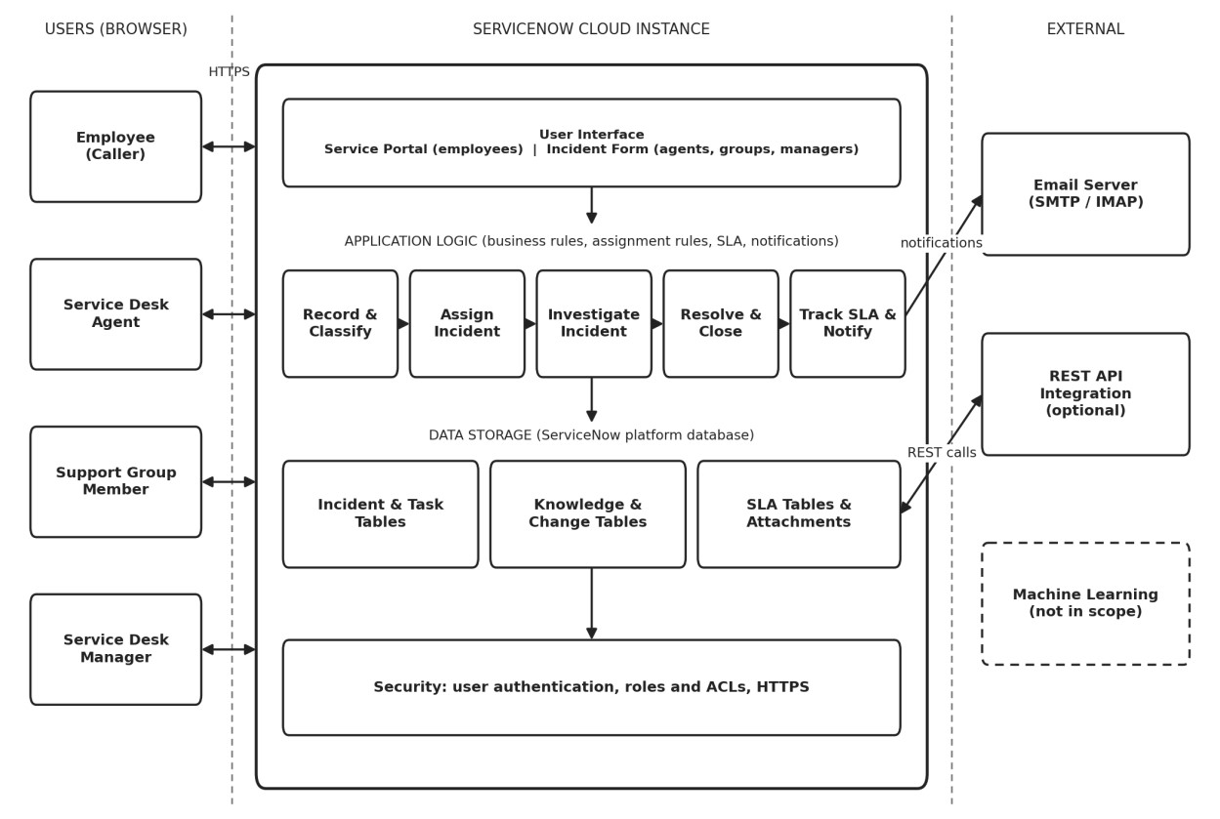
Figure 3: System Architecture
Figure 3 shows that users reach the ServiceNow cloud instance through a web browser over HTTPS. The user interface passes each request to the application logic, where five processes handle recording and classification, assignment, investigation, resolution and closure, and SLA tracking with notifications. These processes read and write the platform database, which holds incident, task, knowledge, change request, and SLA records along with attachments. Security controls such as authentication, roles, and ACLs apply to every layer. Notifications are sent to an external email server, and an optional REST API allows integration with other systems.

4.4 Design Considerations
- Role-based access: each role sees and changes only the records it needs.
- Configuration over customization: platform features are used so administrators can maintain them.
- Traceability: the activity history records who changed an incident and when.

5. PROJECT PLANNING & SCHEDULING

5.1 Project Planning
Phase / Sprint | Tasks | Deliverable
Sprint 1 – Requirements | Identify users, problems, requirements, and the incident workflow. | Problem statement and requirement list.
Sprint 2 – Data and  Design | Define tables, fields, roles, assignment groups, and process flow. | Data design and architecture.
Sprint 3 – Incident  Configuration | Configure the incident form, classification, and assignment. | Incident recording and assignment features.
Sprint 4 – Knowledge,  SLA and Resolution | Configure knowledge search, related records, SLA, and resolution rules. | Investigation, SLA, and resolution features.
Sprint 5 – Testing and  Documentation | Run functional checks, capture output screenshots, and prepare the report. | Test evidence and final documentation.

The sprint plan is a project-planning outline. Actual dates, assigned team members, and completion status should be updated according to the team’s work log.
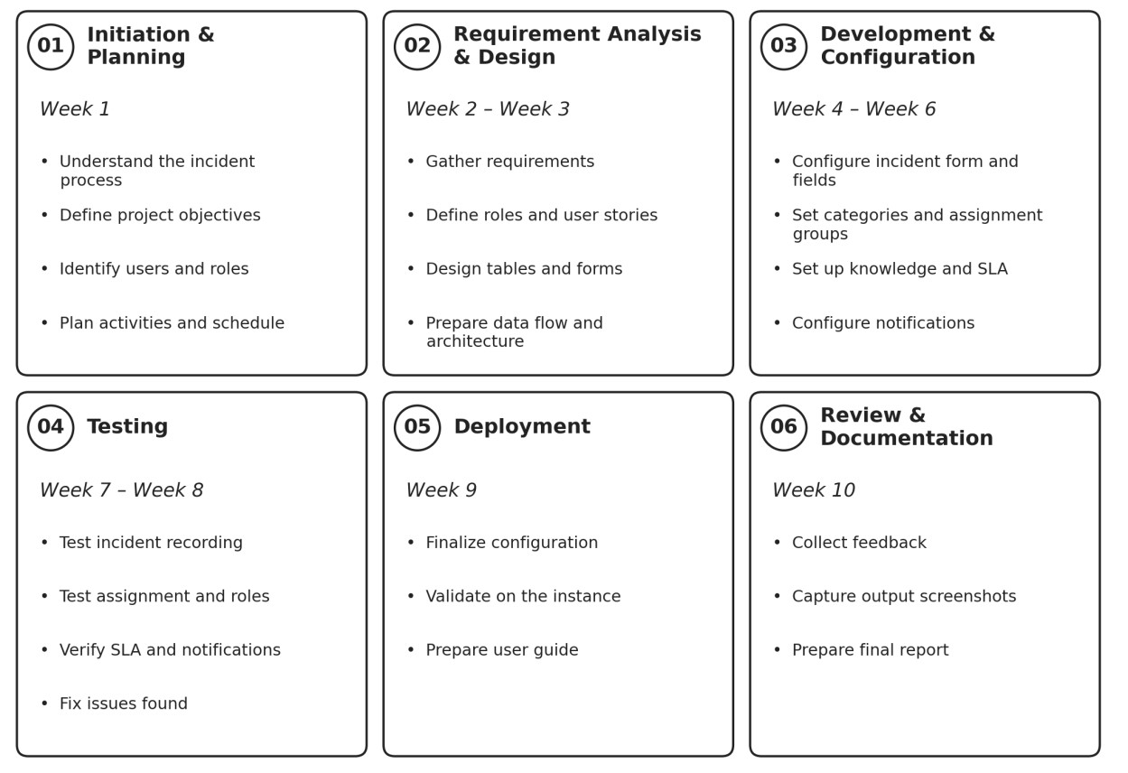
Figure 4: Project Planning and Scheduling

6. FUNCTIONAL AND PERFORMANCE TESTING

6.1 Performance Testing
Testing should verify that the core incident features work as intended and that the time required for common actions is recorded. The results below are a test plan and must be updated with actual measured values from the ServiceNow instance.
Test ID | Test Scenario | Expected Result | Actual Result /  Status
TC-01 | Create a new incident with caller and description. | Incident is created and an incident number is generated. | To be verified
TC-02 | Set category, subcategory, impact, and urgency. | Classification is saved and the priority is calculated. | To be verified
TC-03 | Assign the incident to a support group. | The incident appears in the group’s queue with the assignment recorded. | To be measured / verified
TC-04 | Search and attach a knowledge article. | Matching articles are listed and the selected article is attached. | To be verified
TC-05 | Link a related incident and a change request. | Related records appear on the incident form. | To be verified
TC-06 | Open the SLA information on an incident. | SLA timers and status are displayed. | To be measured / verified
TC-07 | Resolve an incident without resolution notes. | The incident cannot be resolved until the details are entered. | To be verified

7. RESULTS

7.1 Output Screenshots
The following screenshots show the incident lifecycle as configured on the ServiceNow instance, from creating an incident to resolving it.
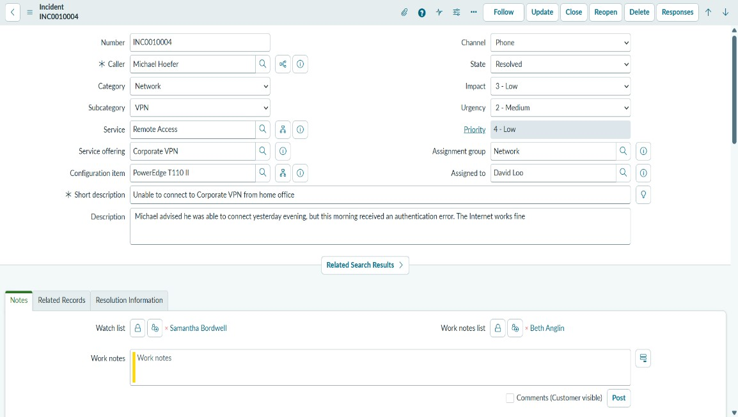

Figure 5: Incident Form – New Incident
Figure 5 shows the incident form with the caller, short description, description, and the incident number generated for the new incident.
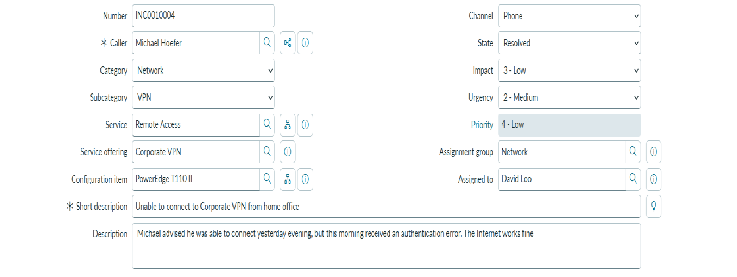
[
Insert scre
enshot: Incident classification fields]

Figure 6: Incident Classification
Figure 6 shows the classification fields: category, subcategory, impact, urgency, service, and configuration item, with the calculated priority.
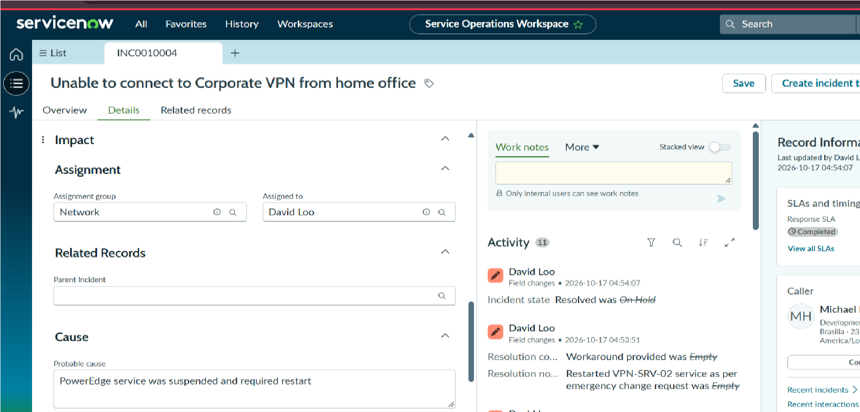
Figure 7: Assignment to Support Group
Figure 7 shows the assignment group and assigned to fields after the incident is routed to a support group.
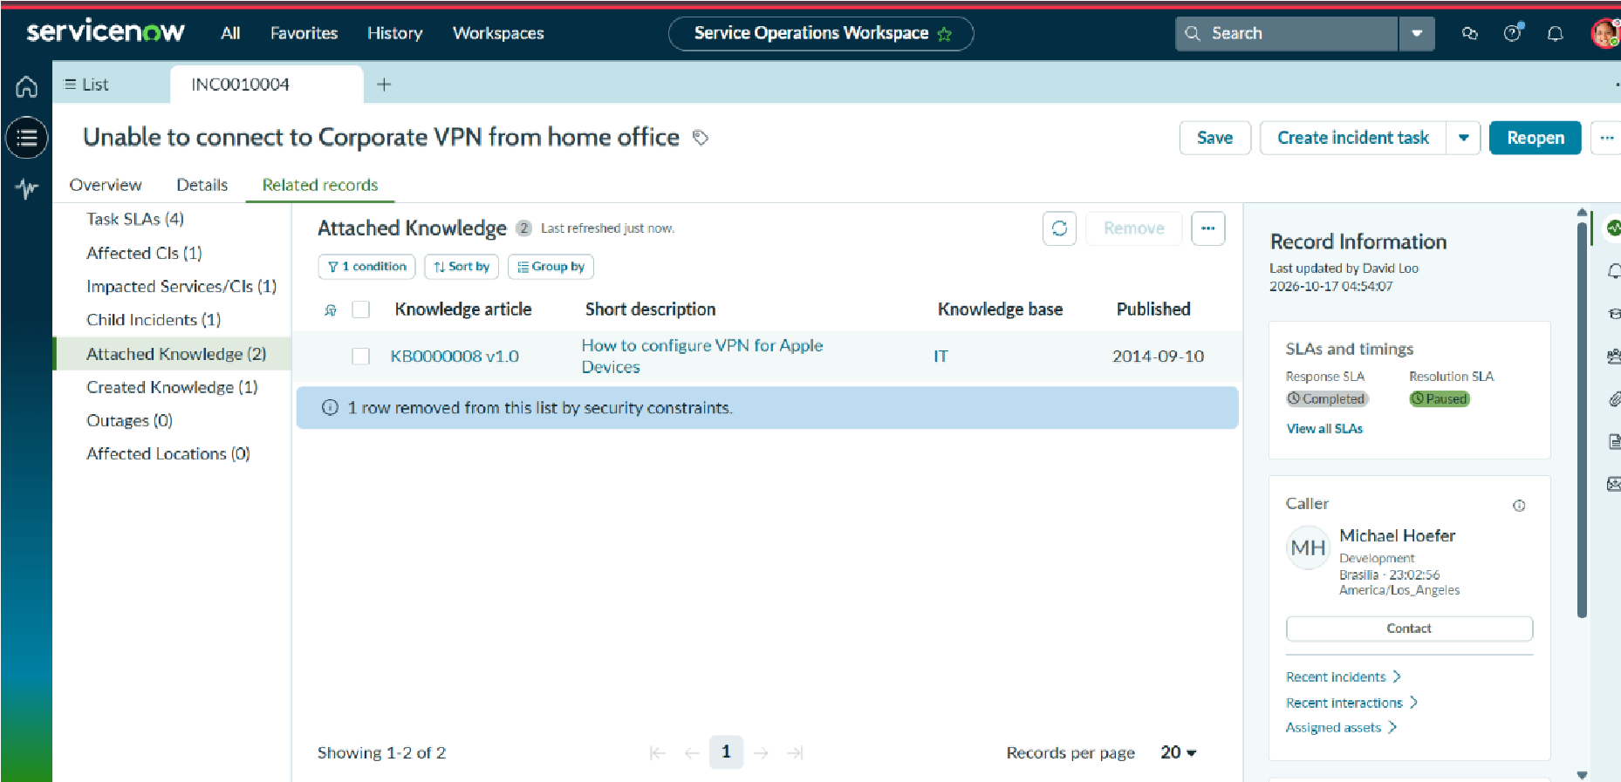
Figure 8: Knowledge Article Attached
Figure 8 shows a knowledge article found for the incident and attached to the record for reference.
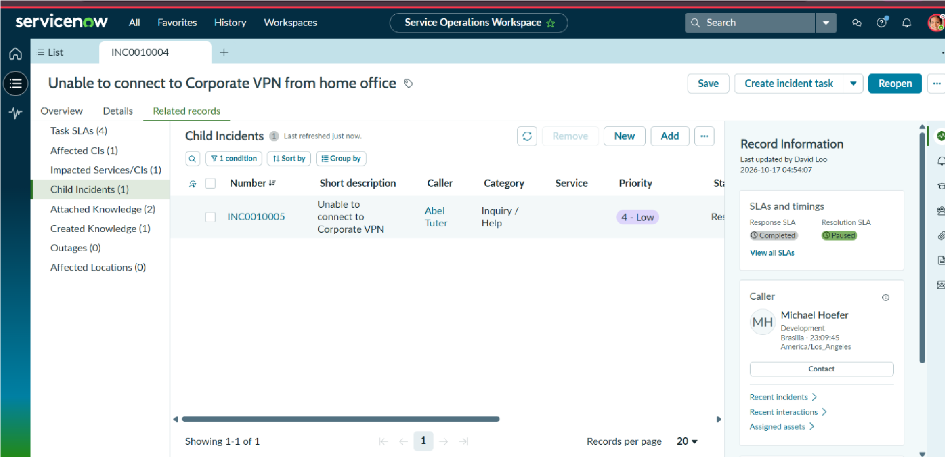
Figure 9: Related Records
Figure 9 shows related incidents and a linked change request on the Related Records tab of the incident.
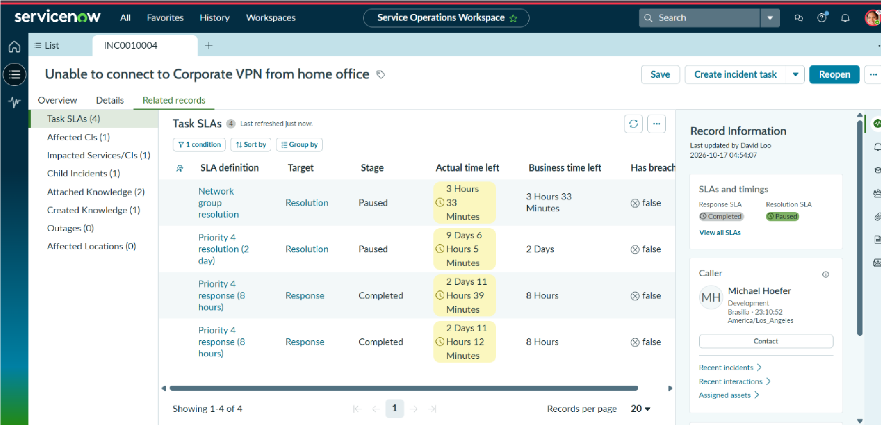
Figure 10: SLA Status
Figure 10 shows the SLA timers and status displayed for the inciden
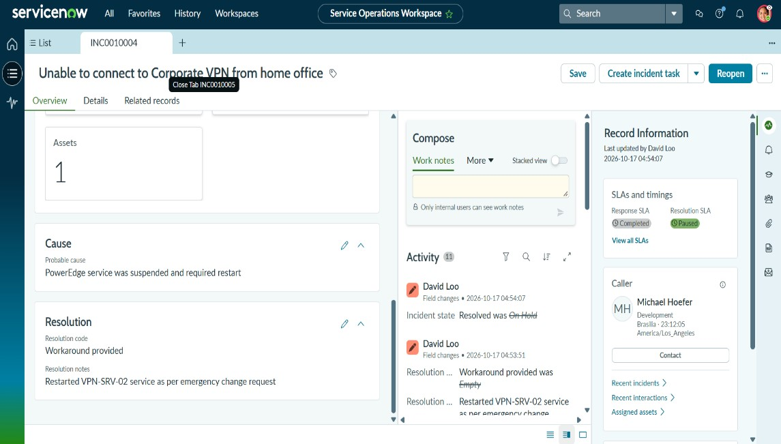

Figure 11 shows the Resolution Information tab with the cause, workaround, and resolution notes entered before the incident is resolved.

8. ADVANTAGES & DISADVANTAGES

1. Advantages
- Centralized Incident Management: The solution provides one place to record, classify, assign, investigate, and resolve incidents. It keeps information organized and makes records easier to find and manage.
- Consistent Records: Structured fields and consistent classification reduce incomplete and inconsistent incident details.
- Clear Assignment and Ownership: Incidents are routed to support groups with a clear owner, which helps reduce reassignment and confusion about who is responsible.
- Knowledge Reuse: Agents and support groups can search and attach knowledge articles and link related incidents, which helps reduce repeated troubleshooting.
- SLA Visibility: SLA status is shown on the incident, so staff and managers can see deadlines and act before they are missed.
- ServiceNow Platform Support: The project uses ServiceNow features such as Incident Management, Knowledge Management, Service Level Management, Service Portal, and workflow configuration, providing a foundation for further development.

2. Disadvantages / Limitations
- Dependence on System Configuration: The proper functioning of the solution depends on the correct configuration of ServiceNow roles, access controls, assignment rules, and SLA definitions. Incorrect configuration may affect record access and the behavior of different processes.
- Email Delivery Dependency: Email notifications depend on the outbound email configuration of the ServiceNow instance. Although notifications can be configured, successful delivery depends on the email settings and mail server and must be verified separately.
- No Integration with Monitoring Tools: The current project does not automatically create incidents from monitoring or discovery tools. Incidents are recorded by users or service desk staff.
- Dependence on Data Quality: The usefulness of the solution depends on agents entering complete details and on knowledge articles being kept up to date.
- Performance and Network Dependency: The performance of the application may vary depending on instance configuration, network connectivity, and the amount of stored data. Response time under different workloads needs to be measured through testing.

9. CONCLUSION
The project “Incident Lifecycle Automation in ServiceNow” demonstrates the use of the ServiceNow platform to organize and simplify the handling of IT incidents. The solution provides a structured workflow for important activities such as incident recording, classification, assignment, investigation, SLA tracking, and resolution and closure.
The project aims to reduce the difficulties associated with incomplete records, unclear ownership, and repeated troubleshooting. By maintaining incident details, assignment information, knowledge articles, related records, SLA status, and resolution details in one platform, it helps organize information and makes it easier for authorized users to access and manage incidents.
The solution also provides separate views and responsibilities for employees, service desk agents, support group members, managers, and administrators. Employees can report issues and receive updates, agents can classify and assign incidents, support groups can investigate and record resolutions, and managers can monitor SLA status. This structured approach aims to improve coordination between callers and support staff.
The use of ServiceNow features such as Incident Management, Knowledge Management, Service Level Management, Service Portal, and workflow configuration demonstrates how a service management platform can be applied to the incident lifecycle. The project provides a foundation for improving the consistency and traceability of incident records.
Although the solution supports the main incident lifecycle activities, further testing and verification are necessary to evaluate its overall reliability and effectiveness. In particular, email notification delivery, application performance, and access control should be tested and measured to strengthen the final evaluation of the project.
In conclusion, the Incident Lifecycle Automation solution provides a centralized and structured approach to incident management. It aims to reduce manual effort, improve record quality, and make the progress of each incident easier to follow. The project can be further enhanced through additional features, improved performance, and integration with other tools in the future.

10. FUTURE SCOPE
The Incident Lifecycle Automation solution can be further enhanced by adding new features and technologies to improve service desk operations, employee convenience, and system efficiency.

1. Virtual Agent for Incident Intake
A chatbot or virtual agent can be added so that employees can report common issues and collect the required details through a conversation, reducing missing information at the time of reporting.

2. Predictive Classification and Assignment
Machine learning features can be explored to suggest the category and assignment group for new incidents. Any such suggestions would need to be tested and validated before being relied on.

3. Self-Service Knowledge Suggestions
The portal can suggest relevant knowledge articles while an employee is describing an issue, which may help resolve simple problems without creating an incident.

4. Problem Management
Recurring incidents can be linked to problem records so that root causes are investigated and permanent fixes are tracked.

5. Advanced SLA Escalations
Additional escalation rules and notifications can be added so that incidents close to breaching an SLA are brought to the attention of the right people earlier.

6. Dashboards and Analytical Reports
Dashboards can show the number of open incidents, incidents by category and priority, SLA performance, and average resolution time to help managers plan.

7. Integration with Monitoring Tools
Alerts from monitoring tools can be connected to create incidents automatically, reducing the delay between a failure and its recording.

8. Mobile Access
Mobile access can allow employees to report incidents and check their status, and allow support staff to update incidents from their devices.

9. Multi-Channel Intake
Incidents can be created from additional channels such as email and chat, so that employees can use the channel they prefer.

11. APPENDIX

GitHub & Project Demo Link
GitHub:https://github.com/varanasikeerthana56/Incident-Lifecycle-Automation-in-ServiceNow
Project Demo: [Add your demo URL or recording link here]
Before submission, verify that the repository and demo links are accessible to the intended reviewers and do not expose credentials or other confidenti data.

